# Assignment Sheet

|  |  |
| --- | --- |
| **Course and instructor name** | GAME Game Dynamics 3 –  Dr. Umer Noor |
| **Assignment name** | Assignment 4 – Collision Response |
| **Grade value** | 10%  Rubric attached |
| **Due date** | In class |
| **Individual or group assignment** | Group |
| **Submission instructions** | Show in class. |
| **Targeting these learning outcomes from course outline** | Calculate collision response between two simple 3D polygons.  Synthesize concepts and requirements for abstract algorithms to formulate solutions for specific game engine components.  Give example(s) of inertia tensors for simple shapes to participate in meaningful discussion about the movement of objects in games. |

# Instructions

Complete the problem on p.9 of the “06collisionResponse” slides (called Lab 4). Also pasted below:

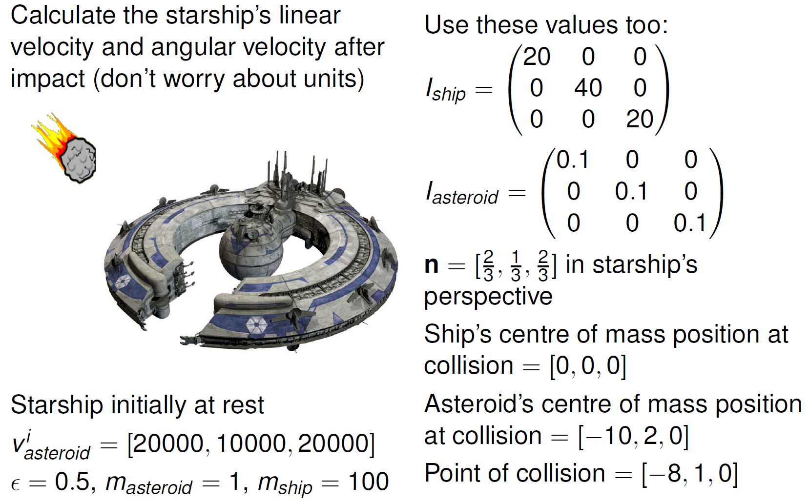

**Answer:**

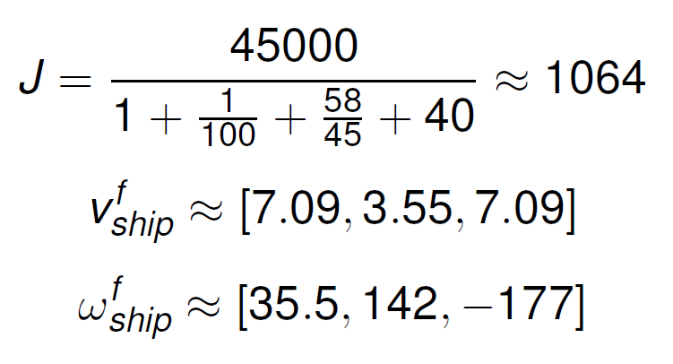

|  |  |  |  |  |  |
| --- | --- | --- | --- | --- | --- |
| Rubric | | | | | |
|  | 5% | 4% | 3% | 2-1% | 0% |
| **J calculation** | Math shown very well | Done to specifications | Missing steps | Missing lots of detail | Largely empty |
| **vf calculation** | Math shown very well | Done to specifications | Missing steps | Missing lots of detail | Largely empty |
| **ωf calculation** | Math shown very well | Done to specifications | Missing steps | Missing lots of detail | Largely empty |

## Rubric

## Grading standard

10/10 - Work so amazing the instructor would only see this once in a lifetime.

9/10 – Exceptional work, rare.

8/10 - Great work, student has full command of the topic.

7/10 - Minor errors.

5/10 - Errors and perhaps a major error.

4/10 - Regular and consistent major errors. Lack of understanding

2/10 - Largely empty.